**Format Endpoints Documentation**

1. By default, when open the project in VuePress docs site at <https://localhost:8080>!

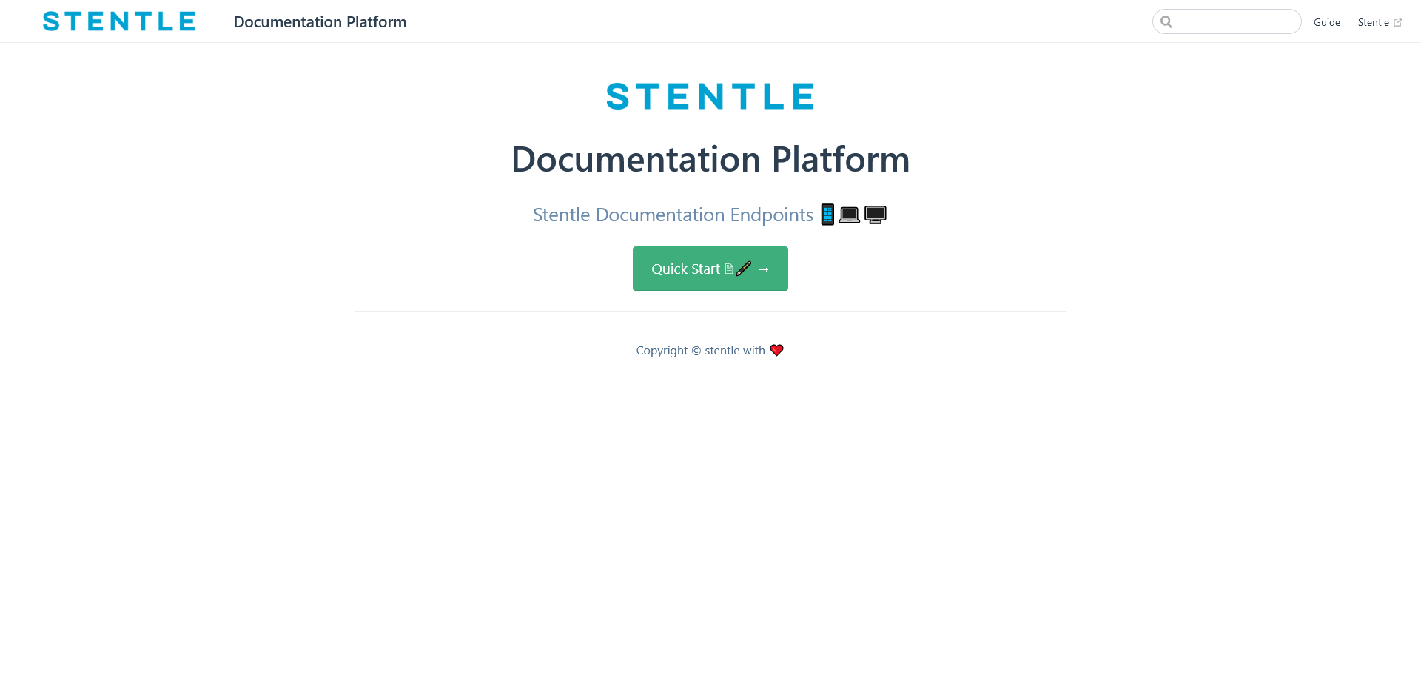

1. Navigation of all documentations (guide) interactive

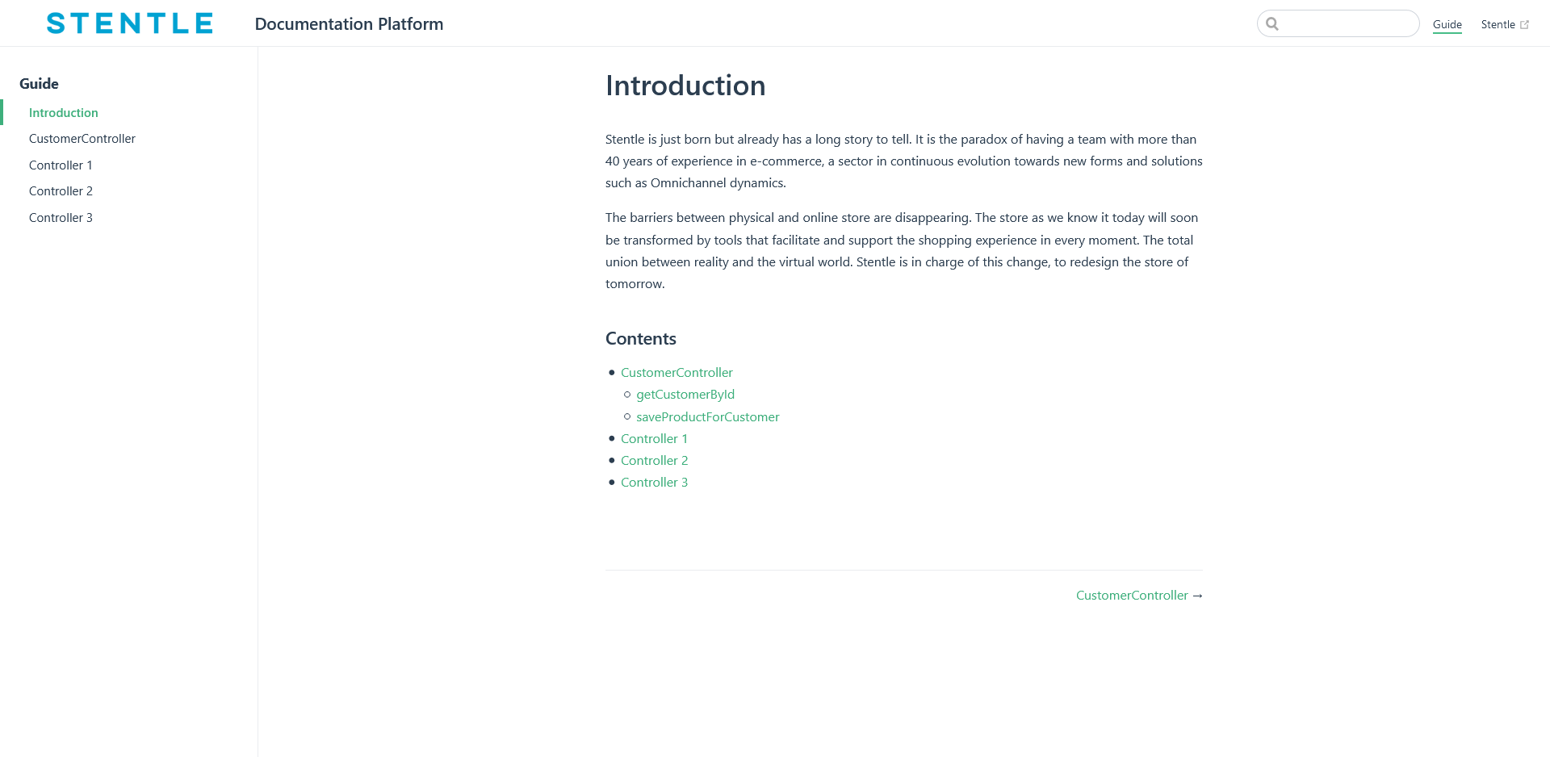

1. Documentation of constructor
   1. Name of constructor (class)

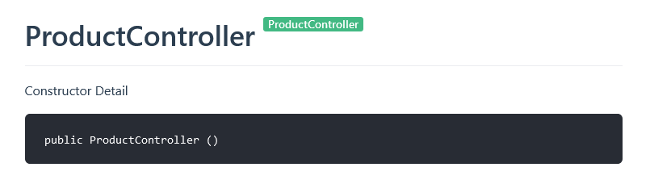

* 1. Details of one methods, type of method, include a description what he do and the postman endpoint, Headers, Payload

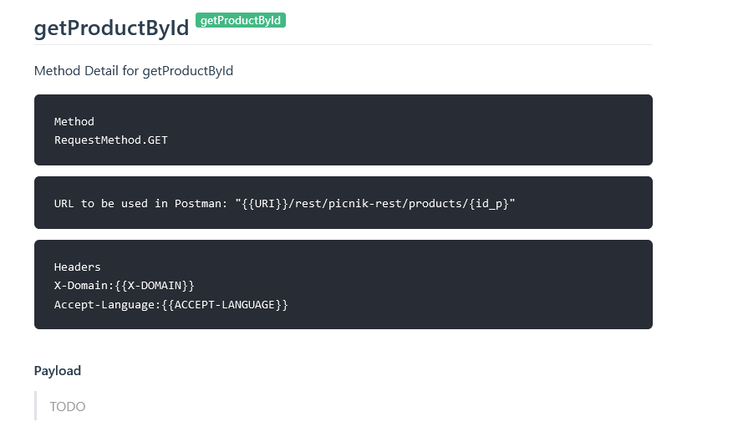

* 1. Parameter that method is using.

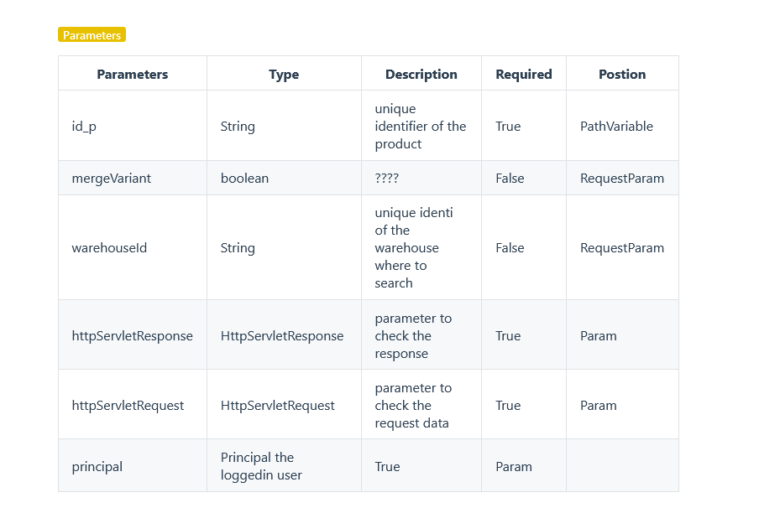

* 1. Retuning data of API

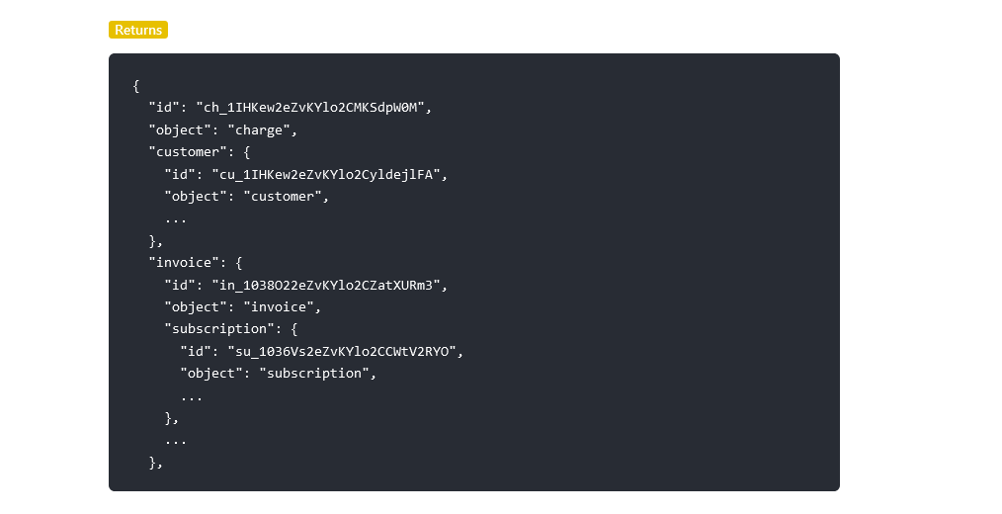

* 1. Specific error of API and info to all types of errors in general.

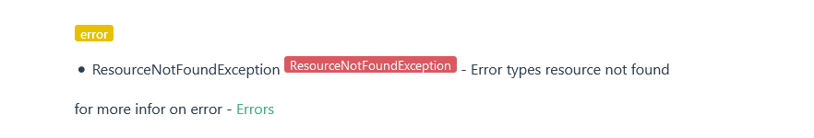

1. Example of constructor **ProductController**

